Code Documentation

In the BridgemanDrone repository, Main.py runs the control loop to make the drone hover in place. The outline is given below.

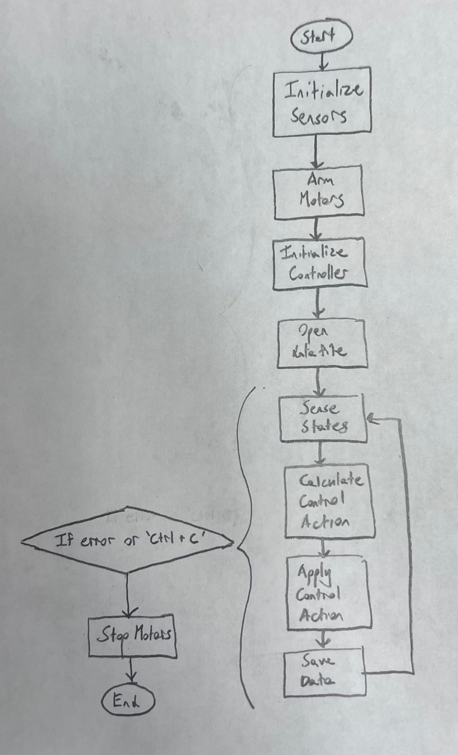

The method for calculating the control action is currently the PD controller described in Control Documentation. Currently (October 23, 2024), it works on the test bench (see Test Bench Documentation). Main.py relies on multiple public libraries as well as custom functions that are stored in the ‘functions’ directory.

**Some quirks of the code:**

1. Each time you open a new ssh, you need to run the command *sudo pigpiod* in the same directory as Main.py to enable the GPIO communications. Otherwise you’ll get an error.
2. Occasionally you’ll get an error that’s related to the BNO055 (IMU), saying it can’t be found or calibrated or something. Wait a few seconds and run it again. Sometimes the error occurs multiple times, but it always eventually goes away on its own.
3. Sometimes, the wifi refuses to work. Make sure you’re on the Vicon wifi and not the DukeBlue wifi. If it continues to not work. Come back the next day and it usually resolves itself.

While Main.py runs, it writes all of the relevant state and control data to a file called ‘data.csv’. The matlab script PlotDroneData.m visualizes the flight data and saves it to the specified file in the ‘ExperimentPlots’ directory.

It is often necessary to run a simplified code to test a new feature. Several old examples of these scripts are saved in the directory ‘TestScripts’.